ASSIGNMENT NO. 10: Window Functions and Analytical Queries

Questions
Q1) Create a MySQL database named SalesDB and a table named SalesData. SalesData Table
Column Name | Data Type | Constraint
SaleID | INT | PRIMARY KEY
Salesperson | VARCHAR(50) | NOT NULL
Department | VARCHAR(30) | NOT NULL
SaleDate | DATE | NOT NULL
Amount | DECIMAL(10,2) | NOT NULL

Insert at least 12 sales records belonging to three different departments.

QUERY:
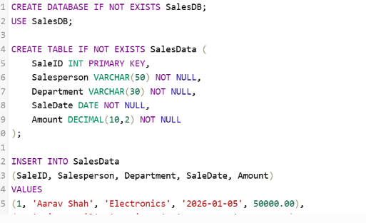
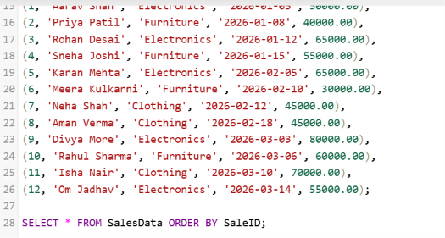

OUTPUT:
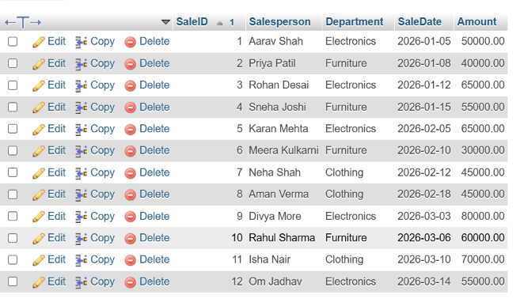

Q2) Write a MySQL query using ROW_NUMBER() to assign a unique row number to every salesperson.
The result should be arranged by sale amount from highest to lowest.
Required Output
Column
Salesperson
Department
Amount
SalesRowNumber

QUERY:
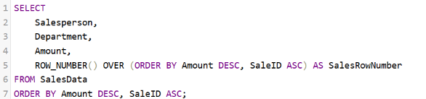

OUTPUT:
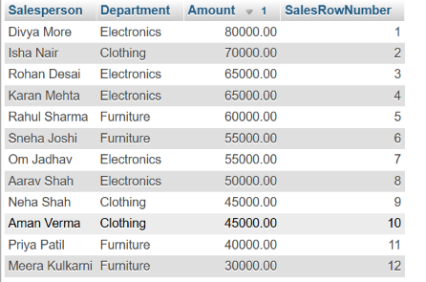

Q3) Write a MySQL query using RANK() to rank salespersons according to their sale amount.
Students having the same sale amount should receive the same rank.
Required Output
Column
Salesperson
Department
Amount
SalesRank

QUERY:
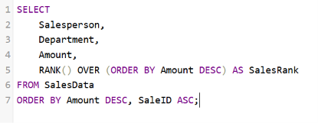

OUTPUT:

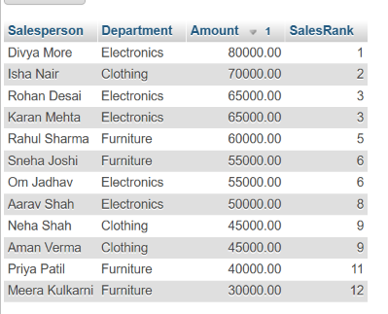

Q4) Write a MySQL query to rank salespersons separately within each department.
Use:
Required Component
RANK()
OVER
PARTITION BY Department
ORDER BY Amount DESC

QUERY:
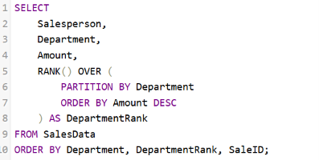

OUTPUT:
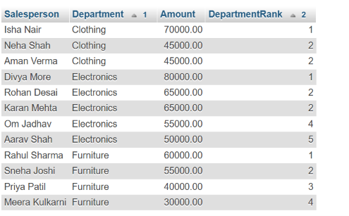

Q5) Write a MySQL query to calculate the running total of sales according to the sale date.
Required Output
Column
SaleID
Salesperson
SaleDate
Amount
RunningTotal

QUERY:
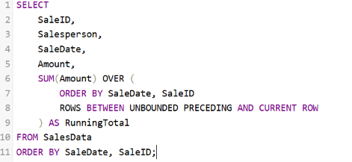

OUTPUT:
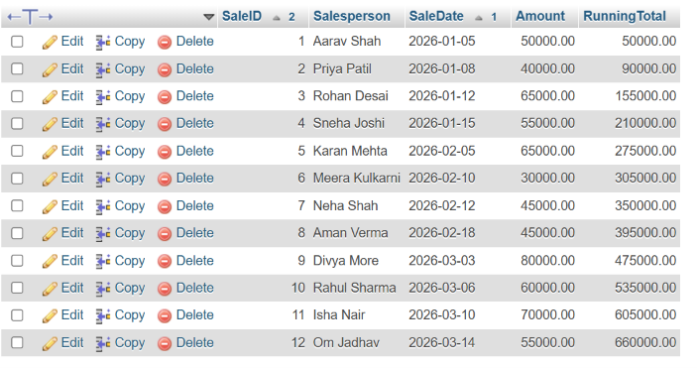

Q6) Write a MySQL query to display the highest-performing salesperson from each department.
The query should:
Requirement
Use ROW_NUMBER()
Partition records by department
Arrange sale amounts in descending order
Use a subquery
Display only the first-ranked salesperson from every department

QUERY:
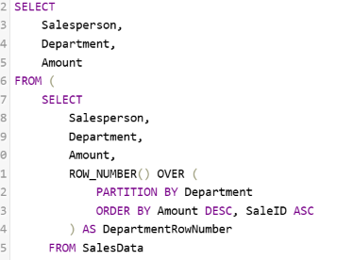

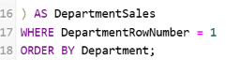

OUTPUT:
